Meeting Minutes

Metropolitan Utility Coordinating Council
MUCC, C/O Troy Klein, 220 NW 2nd Ave, 11th Floor, Portland, OR 97209

March 28th, 2012
Our next meeting will be April 25th, 2012
At the Francis Xavier’s Restaurant, 1933 NE 181st St, Gresham
http://www.yellowpages.com/portland-or/mip/francis-xaviers-restaurant-11967024/map?lid=11967024 (Control +Click mouse on link for Map Directions & Menu)

ATTENDEES: See attached listing.
__________________________________________________________________________________________________

REPORTS:

Treasurer’s Report for February 2012:
M Bank Visa

Beginning Balance $ 3,071.49 $ -
Ending Balance $ 4,641.49 $ -

1 –Deposit of & $1126.81 (from closure of Golf account) 1-Void check $300 1-Check for postage $34.20

Payments / Purchases / Income:
As a non-profit organization, all monies collected go for supplies/events to educate the public!
Our ending balance (all accounts) must be under $5,000 at the end of the year or we will have to pay taxes.

Damage Report: See the end of the minutes.

We must have five (5) entities reporting monthly – be sure to report your damages by the 18th of each month!
The Common Ground Alliance (CGA) encourages the use of their Damage Information Reporting Tool (DIRT). You can check this out at www.cga-dirt.com

P&E Report (Publicity and Education):

P&E General: Send your ideas to Don Patterson (dwp@nwnatural.com) and Anita Floyd (anita.floyd@qwest.com)

New:

Per Gary Hyatt, Don Patterson is looking for events in all 3 counties. Please let Don know if you know an event where we may be able to participate in.

Old:
Don Patterson reported the possibility of putting ads in some Bi-lingual local newspapers. He has been in contact with someone associated with the Asian Reporter. That person has contacts with other local Bi-Lingual newspapers. Don asked for ideas for Annual Events, especially for Washington County.

The OUNC has purchased several table top versions of the booth that we all use in the home/vendor shows. The plan is for these to be shared among the OUCC. Each council will need to buy a table cover that will be personalized for their respective group
Anita Floyd announced that they have contracted out 6 events with Radio Disney. They will be making big cut outs of Dialer & Digby dogs. They will also be designing a new 811 dig safely brochure.

Anita Floyd asked “What topics” would like to be discussed at the Joint States Meeting in September 2012. She announces there will be 3 Locator Trainee Courses in 2012. She said there will be Letters of Solicitation going out to large companies for the Radio TV advertising.
Damage Prevention videos are now available from the CGA.

2012 vehicle calendars are now available.

Anita Floyd suggested that if there are any concerns with the wording or if you have questions or suggestions on the OAR’s, to please contact Jennifer Carter w/ Emery & Son’s @ Jennifer@emeryandsons.com, as they are being worked on at this time.

We are looking for local community sponsors! Please talk to any of our local vendors who sell/rent items where it would benefit us and the public to have our handout in the store. If the store will agree to have our handouts available for the public, pass their contact info on to Don to get it set up. If the store wants to make a donation for a giveaway at one of the events that we attend, that would be great as well, but it is not required. We mostly want to get our handouts into their stores so the public has access to it!
An event that is coming up that we can discuss attending is the Mississippi Street Fair. More details to follow.
See Upcoming Events / Meetings for the Locator Training Sessions this year.

Columbia Gorge/Hood River areas are planning radio ads to promote 811 as well as using small newspaper ads. Don Patterson has checked into our local area and found that there is one radio company that owns about a dozen smaller newspapers in the local region. We can run a single ad (3.5” x 4” in color) in these local papers for just $145/month.

Requests for cards/pens/hats/other items are being downsized because OUNC doesn’t want to run out of inventory. Please only order what you really need.

811 CAMPAIGN:
Adam Franco w/ OUNC announced that the 811 Damage Prevention Bike was unveiled at the 2011 Greater Chesapeake Damage Prevention Training Conference November 2, 2011, in Ocean City, Maryland. For more details go to:
http://designbyjoyce.com/pauljr/811_bike.html

Home Depot is breaking out in the western region. Go into your local Home Depot and if you do not see the 811 info, ask at the Contractors desk.
In Oregon, the stores will carry Key Chains for all equipment and color code cards. The “Associates” who will be trained to answer questions will have patches on their aprons.
The OUNC meets the 2nd Wednesday of the month at the One Call Center in Portland.
You may go to www.call811.com website for more information.
____________________________________________________________________________________________________________

Upcoming Events / Meetings:

OUNC BOARD MEETING: Wednesday, April 11th, 2012 @ Monarch Hotel 12566 SE 93rd Av., Portland/Clackamas OR. Damage Prevention Forum: 8:00am to 10:00am
Board Of Directors Meeting: 10:00am to 3:00pm

CLACKAMAS COUNTY HEALTH & SAFETY FAIR: Wednesday, April 25th, 2012 10:00am to 4:00pm @ The Development Services Building at Clackamas County Building, 150 Beavercreek Rd., Oregon City.

LOCATOR TRAINING SESSION: Tuesday & Wednesday, May 8^{th & 9th}, 2012 8:30am – 4:00pm @ Sun River Resort, 17600 Center Dr Sunriver, OR. For registration questions, contact: Laura Venida 503-236-3721 OUNClaura@aol.com

OUNC/OUCC 2012 BOARD MEETING: Wednesday, May 9th, 2012 @ Sunriver Resort, 17600 Center Dr. Sunriver, OR. OUNC meets in the morning & OUCC meets in the afternoon.

JOINT STATES MEETING: Tuesday – Thursday, September 18th – 20th, 2012 @ Ocean View Resort 414 N Prom, Seaside, OR -Registration Forms are available now @ http://www.oucc.net/joint-states-registration.asp and hotel reservations available @ http://www.oceanviewresort.com/

OUNC/OUCC 2012 BOARD MEETING: Thursday, September 20th, 2012 @ Ocean View Resort 414 N Prom, Seaside, OR. OUNC meets in the morning & OUCC meets in the afternoon.

LOCATOR TRAINING SESSION: Tuesday & Wednesday, October 9th ^{& 10th}, 2012 8:30am – 4:00pm @ Wildhorse Casino, Pendleton, OR. For registration questions, contact: Laura Venida 503-236-3721 OUNClaura@aol.com
_______________________________________________________________________________________

OLD BUSINESS:

RAA -
Date of next meeting is unknown at this time. You are invited to attend, but you can only watch & not participate. Hearings are at the PUC Building at 550 Capitol St NE, Salem. Be sure to bring change for the parking meters if you attend. The OUNC has asked Michael Thompson to put together a summary of the RAA hearings. This would benefit the local councils to help promote education to the local contractors in the areas where infractions are the highest.

Jarrod Morrison told us that he did talk with the Friends of Tree’s people about giving the locate companies extra time when they call in a lot of tickets at once, and about waiting for locates before the start to dig. Jarrod asked for feedback from locate companies, as he wants to make sure they do work with them.

Gary Hyatt announced that the Northwest Resource Federal Credit Union account has been closed. The money from that account has been deposited into the M Bank account.
Gary announced some of the Guest Speakers that have committed to speak at the Joint States Meeting in September. There are also 9 venders so far. The registration fee for this event is $125, rooms are available for $86. See Upcoming Events / Meetings above for dates & registration links.

Jarrod Morrison spoke about the need for more promotion on dig regulations & the education of “reasonable accuracy”. He said that this topic was brought up at a board meeting.

Gary Hyatt and Jarrod Morrison will be getting together with Friends of Tree’s and talking with them about calling in so many tickets on such a limited time frame.

Gary asked for a volunteer for the Damage Chair position, and Dawn Haase was kind enough to take on the duties. Thanks Dawn!

Gary has ordered the Project Pipeline DVD from Underground Focus Magazine that will be presented at our next meeting. It is a 16 minute video & we may have someone from Williams Pipeline do a follow up presentation.

-Amended from January minutes -A motion was passed to remove Sheri Clark, Marcy Johnson & Jarrod Morrison from the M Bank accounts and add Troy Klein to the account. Both Gary Hyatt & Troy Klein will be signers on the account. A motion was passed to close the Northwest Resource Federal Credit Union account & merge it with the M Bank account.

Jarrod Morrison announced that we now have an EIN it is 45-3941258, he said to make sure we always associate that # to “MUCC”.

Don Patterson was asked to put together a letter to mail out to local banks, notifying them that if they have offsite ATM’s that would have phone lines in the public ROW’s to join the One-Call, as those lines should be located. Anyone who can help with this project, please contact Don Patterson.

Adam Franco with OUNC announced that the web map URL has been added to the one-call tickets

If you know of any websites that could benefit by having a link to our website, please pass the website on to Don Patterson to check it out. Getting our link onto other websites is a good way to be visible online and can reach many people.

The reporting of contractors digging without locates was discussed and was suggested by Anita Floyd that OSHA could be called & they or the Counties could come out to job sites and shut contractors down.

Jarrod would like to form a committee to review the old Bylaws (adopted on March 25, 1998) and bring them up to date.
Adam Frank with OUNC told us that the disclaimer has been added now regarding the use of contact information that Jarrod Morrison talked about in May.

Gary Hyatt reminded everyone to pass along the reminder to their companies, that when calling in locates to please call in specific marking instructions rather that requesting to locate the entire lots.

Some ideas were mentioned of how to get the “811” advertised by the utility companies to the home owners, by either a flyer in the bills or a stamp on the envelope, some utility representatives said they would ask around to see if there was something that could be done.

REMINDER…Send your current and/or upcoming projects to Marta Hashash at marta.hashash@locatinginc.com and they will be attached to the Minutes e-mail so everyone will know where projects are or will be happening and your company can schedule accordingly.

811 Locate Requesting is available 24/7! Don’t wait until first thing Monday morning to call in your locates – you’ll find the lines are packed with everyone else calling at the same time! Call Saturday or Sunday if you want to get your request in early. Still expect two (2) business days for the locates to show up!
Should you encounter an un-located utility while excavating – stop digging, call 811 to report it immediately, determine that there is no immediate danger, and you can continue working (if your project allows) using extreme care in the affected area. See Page 23 (5) in the Standards Manual.

NEW BUSINESS:

Gary Hyatt announced that the Governor has proclaimed April 2012 Safe Digging Month! He reminded us all that the Joint States meeting is on September 18th through the 20th. The deadline for registering is September 10th. Please register ASAP.

Dawn Haase is now on board doing the damage reports, she passed copies around. See attached copy.

Jarrod Morrison shared that he is trying to get the 811 Damage Prevention bike to be shown at the Starlight Parade & Rose Parade this year, as Portland General Electric sponsor these two parades. Jarrod also mentioned that soon Portland General Electric customers will be able to enter a drawing on their website when they “Promise to call 811” customers will then have a chance to win some great prizes. He also informed us that the One Call Board Pipeline Safety Group is looking into advertising 811 at local rodeos.

Adam Franco notified us that the ticket count is up 7% from this time last year. Adam also informed us that excavator information can be accessed via the ITIC site, (but special access has to be granted by the center). If someone is interested they can speak with the database department to get setup to access the report. Using the Contractor report you can obtain all available contact information for excavators based on the following parameters:

Date range during which a locate was filed.
District codes that were notified on the ticket.
County the work was taking place within.
Type of locate filed.

Gary Hyatt reminded us all that if an excavator hires a sub-contractor that, that sub-contractor is required by law to call in their own locate ticket.

The 8th Annual Golf Tournament has been set for July 13th, 2012. Gary Hyatt asked if there is anyone interested in joining the planning committee to please let him know.

Finally, Carl Clinton with Clackamas County reviewed the Oregon Revised Statutes regarding monuments. Please see attachment.

REMINDER…Send your current and/or upcoming projects to Marta Hashash at marta.hashash@locatinginc.com and they will be attached to the Minutes e-mail so everyone will know where projects are or will be happening and your company can schedule accordingly.

_____________________________________________________________________________________

Remember – CCC – Communicate, Coordinate, And Cooperate!
______________________________________________________________________________________________________________________________________________

VOLUNTEERS NEEDED: As you have read, there are a variety of opportunities for all to volunteer and help spread the word of our Call before You Dig message. These are great opportunities to network and get to know each other better. Take advantage of these opportunities and make new friends. If you are able, make yourself available to be on a committee or to volunteer on any of the upcoming projects and events these next couple of years. This is what this Council is all about and how we strive to be excellent!
_______________________________________________________________________________________

Oregon Utility Notification Center  www.digsafelyoregon.com | Oregon Utility Coordinating Council  www.oucc.net

Check out the websites for info on the Oregon Dig Law, upcoming events and on your local Council(s).
There are new changes to the website – check them out.
Also available: see information on Best Practices at www.commongroundalliance.com
_______________________________________________________________________________________

Respectfully submitted by Marta Hashash.
_______________________________________________________________________________________
The next meeting: Date: April 25th, at 11:30am
Location: Francis Xavier’s Restaurant 1933 NE 181st St. Gresham, OR

http://www.yellowpages.com/portland-or/mip/francis-xaviers-restaurant-11967024/map?lid=11967024

The 2012 schedule is the 4th Wednesday of each month (November is

the week after Thanksgiving this year) and December (no meeting).

January 25th February 22nd March 28th April 25th
May 23rd June 27th July 25th August 22nd

September 26th October 24th November 28th Dec - No meeting

2012 MUCC Executive Board
MUCC, C/O Troy Klein, 220 NW 2nd Ave, 11th Floor, Portland, OR 97209

PRESIDENT: Gary Hyatt, NW Natural, 220 NW 2nd Ave, 3rd Floor, Portland OR 97209

Office - (503) 226-4211 ext 4320, gfh@nwnatural.com

VICE PRESIDENT / TREASURER: Troy Klein, NW Natural, 220 NW 2nd Ave, 11th Floor, Portland OR 97209, Office - (503) 226-4211 ext 2442, Cell – (503) 341-7862, tak@nwnatural.com

SECRETARY: Marta Hashash, Locating Inc, 6601 NE 78th Ct, Portland OR 97218
Office – (503) 255-4634, Fax – (503) 254-7469, Cell – (503) 302-3970 marta.hashash@locatinginc.com

PUBLICITY & EDUCATION: Don Patterson, NW Natural, 220 NW 2nd Ave, 3rd Floor

Portland OR 97209, Office - (503) 226-4211 ext 4387, Cell – (503) 806-0845
Fax – (503) 273-4822, dwp@nwnatural.com

DAMAGE CHAIR: Dawn Haase, Clackamas County DTD Eng, 150 Beavercreek Rd., Oregon City, OR 97045

Office – (503) 742-4682, Fax – (503) 742-4659, Cell – (503) 789-5728 dhaase@co.clackamas.or.us

2012 MUCC PAID MEMBERS

As of 04-11-12

Damage Report: In 2012 we must have a minimum of five (5) damage reports per month.
Please submit your damages within 30 days.
The following is from the Website http://oucc.net/ taken April 16, 2012.

January 2012: Five submittals for damages…

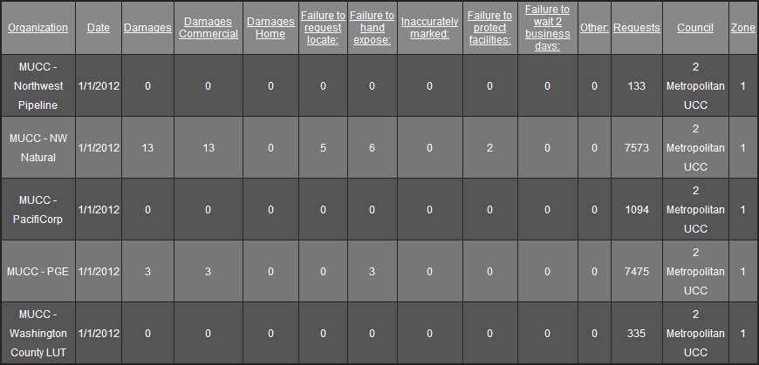

February 2012: Four submittals for damages…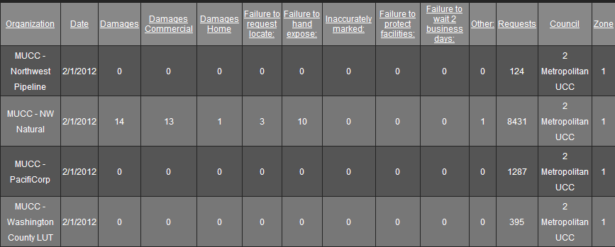

March 2012: One submittals so far………